Lab x: Timing Evaluation and Improvement

Author: Seth Ricks
Lab Partner: Ian Fleming
Date: 11/24/2025
Class: ECEN 340

Purpose:
- To learn how to use Vivado’s timing analysis tools
- To learn how to use Vivado’s timing analysis tools
- To learn how to make use of Vivado’s “Device” view for timing analysis
- To learn how to predict the maximum operating frequency of the design
- To become familiar with Artix 7 structure
- To learn how to make timing improvements
Procedure:
The first objective of this lab is to evaluate the timing of Lab 8’s memory design to determine its maximum operating frequency for:

A) An 8-bit adder using the “+” operator
B) An 8-bit multiplier using the “*” operator
C) An 8-bit multiplier using the instantiation of Lab 5, the continuous assignment (dataflow) multiplier.

In other words, for part B, you will replace the “+” operator in lab 8 with an instantiation of your Lab 5 multiplier to evaluate its maximum speed. For part C, you must write a new and improved multiplier module.

The final objective of this lab is to speed up the clock rate of the multiplier by pipelining the design for part C.

Part 1 (First lab day).
- Make sure the “create_clock” line is uncommented in the constraints file. This line will set up the timing constraints for the analysis. The period for the analysis will be 10ns.
- In Vivado, execute the Lab 8 memory project all the way to the “Implementation” stage, and open the implemented design.
- Under the “Implementation” menu, select “Edit Timing Constraints” to make sure the timing will be evaluated at a 10ns period.
- Under the same menu, select “Report Timing Summary”. Use the default settings and generate the summary.
- Record the “Worst Negative Slack” number. A positive number will indicate the design meets timing requirements.
- Click on the WNS number and you will be able to view the timing of each path. The default view shows the slowest path first.
- Record the path starting point and the path stopping point for the 4 worst paths.
- Activate the “Schematic” view and observe what happens as you select different paths in the timing report.
- Activate the “Device” view and make the same observation (you will need to zoom way in!).
- Repeat this process for the “*” operation instead of the “+” operation.
- Repeat the process again for the Lab 5 Data-flow Multiplier (instantiate the Lab 5 multiplier in the memory lab).

Part 2 (Second lab day).
Implement a pipelined multiplier and evaluate its speed by instantiating it into your lab 8 sequential memory.

Since pipelining takes multiple clock cycles to complete a multiplication operation, the result won’t be ready until a few clock cycles after the input memory is accessed.

What must you do to force the product of the input memory data to be written to the corresponding address in output memory?

Pipelining Hint: If product = p0 + p1 + p2 + p3 + p4 + p5 + p6 + p7 (see lab 5), it is possible to pipeline the operation in using the technique in Figure 1.
p0
p5
p4
p3
p2
p1
D
Q
D
Q
D
Q
D
Q
D
Q
D
Q
product
p7
p6

Figure 1, Pipelining the Partial-Product Sums

Results/Report:

Part 1:
In this part of the lab, we were to test the timing for both the “+” and the “*” operation. This can be seen in the Part 1 section of the instructions. The Worst Negative Slack (WNS) number was 2.741 ns. We also recorded the 4 worst paths. These were:
  - Addrcont/addr_reg[1]/C OM/mem_reg_0_15_8_8/SPI/I
  - Addrcont/addr_reg[1]/C OM/mem_reg_0_15_4_4/SPI/I
  - Addrcont/addr_reg[1]/C OM/mem_reg_0_15_7_7/SPI/I
  - Addrcont/addr_reg[1]/C OM/mem_reg_0_15_5_5/SPI/I

We then activated the schematic view, and observed what happened when we selected the different baths in the timing report. This can be seen in Figure 1 below.

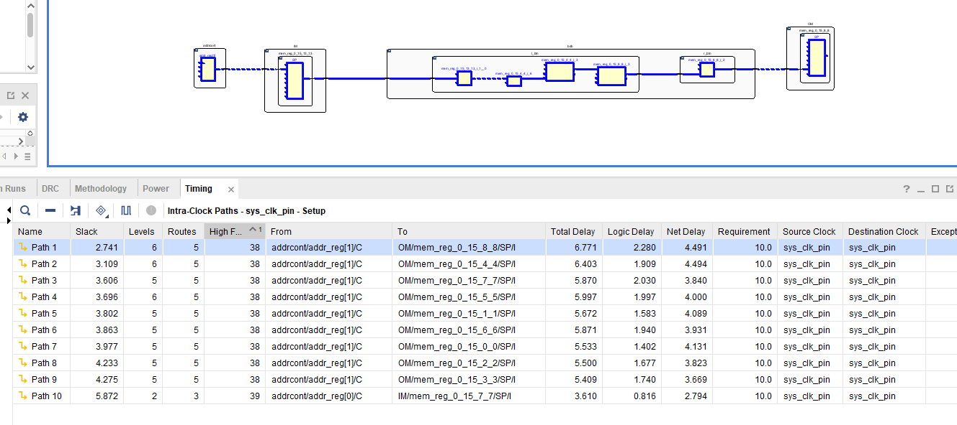
Figure 1

We also looked at the Device view, which was a new one for us. We had to zoom in very far to see the paths it was talking about. The Device view with one of the timing paths selected can be seen in Figure 2 below.

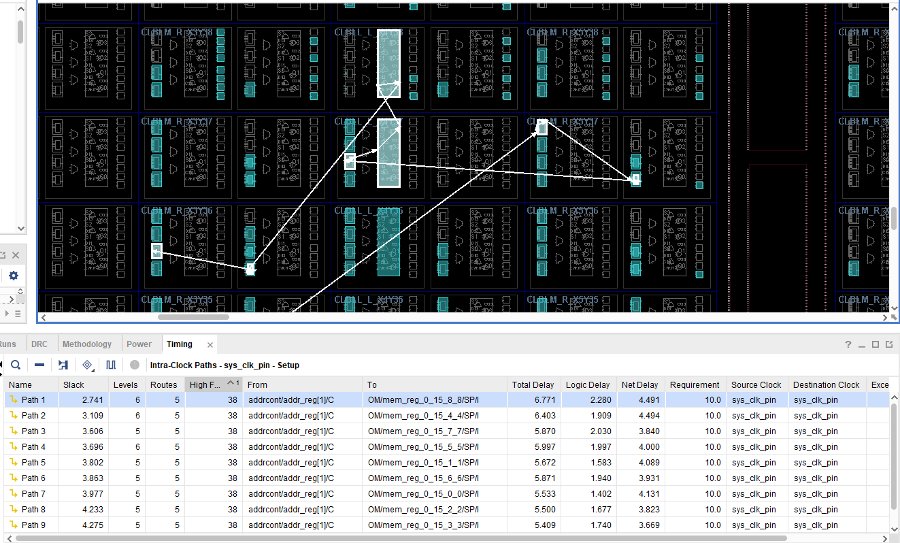
Figure 2

As instructed, we then repeated this process changing the “+” operation to the “*” operation in Lab 8. We found that the WNS for this operation was 0.249 ns, much worse than the first. A schematic with one of the timing paths selected can be seen in Figure 3 below.
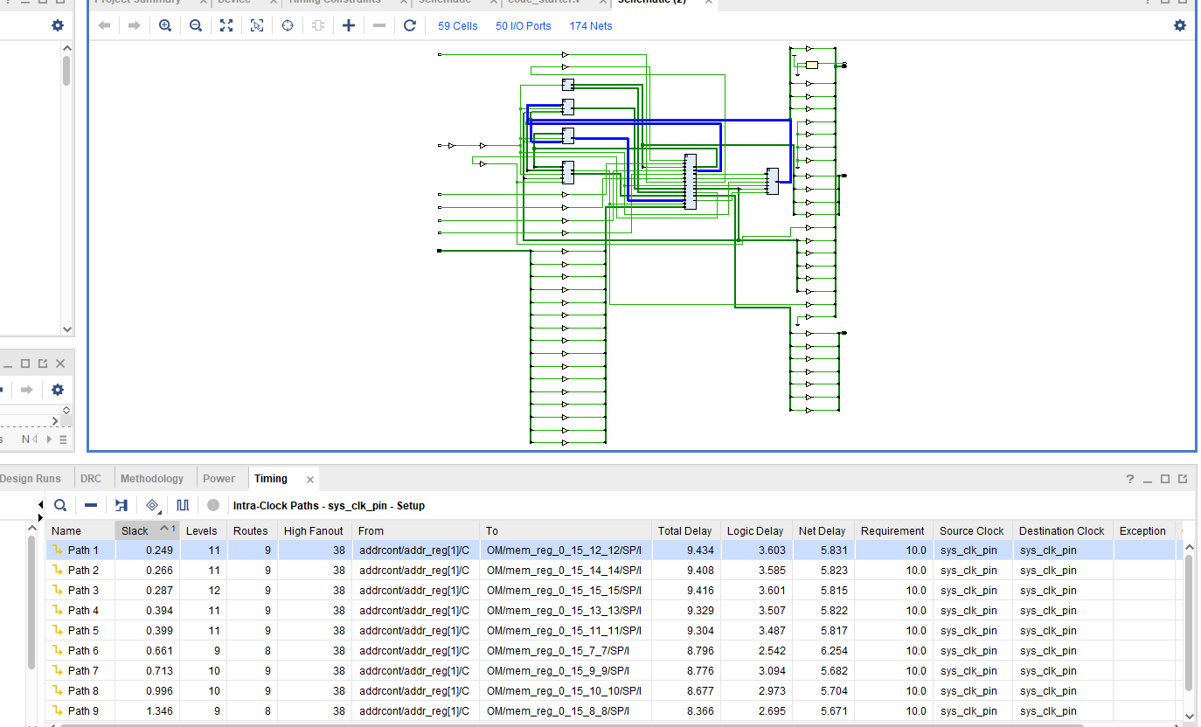
Figure 3
As with the first operation, we also looked at one of the timing paths in the Device view. This can be seen in Figure 4 below.
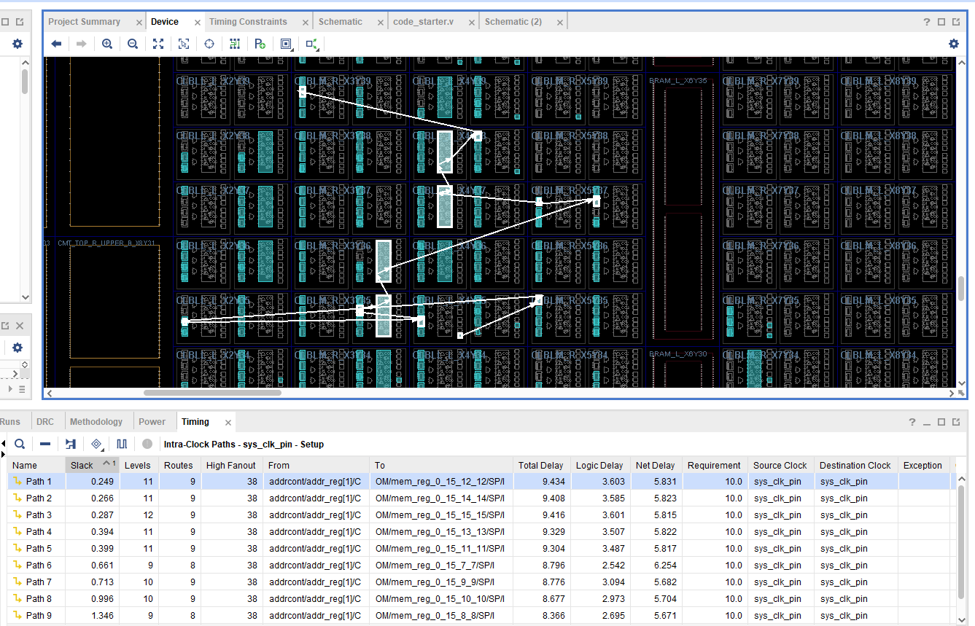
Figure 4

Part 2:
The second part of the lab was much harder to understand than the first. We were tasked to take the multiplication operation and use pipelining to speed it up. We did this by replacing the multiplier operation from before with an instantiation of our own pipelined multiplier, as can be seen in our code in Figure 5.
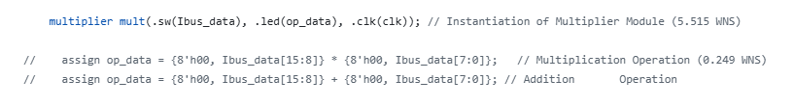
Figure 5

As we were asked to make in the instructions, we created a pipelined design with three stages. We did this by creating three flipflops, which we did by creating three always blocks. The logic in each block is passed on to the next on the clock edge. PP0, PP1, etc. is passed into the first staged, represented by S1. S1 is then passed into S2, which is then passed into the final product. An image of this code can be seen in Figure 6 below.
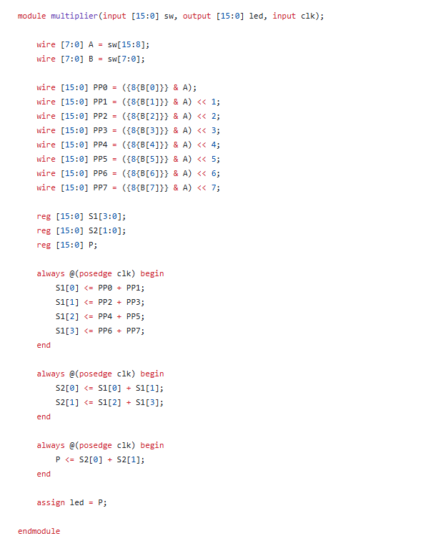
Figure 6

After synthesizing and viewing the implementation of this code, we saw that the WNS increased a lot, to 5.515 ns. This is better, because it means that we have more setup time available. To see what the fastest frequency that this code could run at, we experimented with the period of our clock rate. After some trial and error, we found that the fastest we could run our clock was at a period of 6.30 ns. This corresponded to a frequency of 158 MHz. We looked at the Design Timing Summary again and found that our Worst Negative Slack became 1.027 ns. An image of the Design Timing Summary can be seen in Figure 7 below.

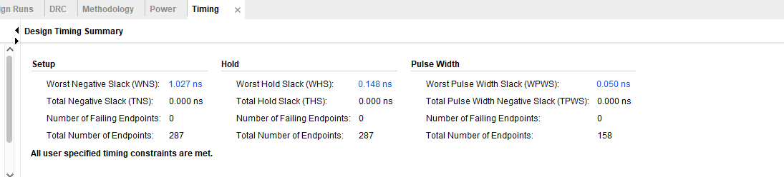
Figure 7

Conclusion:
If pipelining is so much faster, then why can’t we do it for everything? The answer comes with the understanding of how pipelining is used. When the first stage of an operation of completed, it is passed onto the next stage. The first stage of another operation can then be performed, during the same time that the second stage of the first operation is performed. This means that pipelining is only useful if we are going to do multiple operations of the same kind in sequence, so the pipeline can stay full. If we only have one operation to do, then pipelining doesn’t make it finish any faster. For example, with our faster clock period of 6.30 ns, this clock period must be passed through 3 different stages. So, the clock period for the entire operation in the pipelined version is 6.30 * 3 = 18.9 ns, much slower than 10. However, if we are passing in a new operation every 6.3 ns to each stage, this becomes much faster.
In conclusion, pipelining makes our data processing much faster when we have a lot of operations to do in parallel. It does not help us as much when we only have one operation to do because its latency doesn’t shrink. But because computers often have billions of operations per second, pipelining can really help to speed things up.

